"Beautiful South· Guangxi—China art exhibition" opens at national art museum of China
Zhou Li^{1, a, *}, Xu Shengchao^{1, b},
¹Guangxi Fine Arts Publishing House, No. 9 Wang yuan Road, Qing xiu District, Nanning, Guangxi Zhuang Autonomous Region 530023, China
a.zhouli_8533@126.com,b.xu_chao_901127@sina.com
*Corresponding Author
Abstract: On the second anniversary of the Speech at the Forum on Literature and Art, "Beautiful South· Guangxi—China Art Exhibition" opened at the National Art Museum of China on December 9, 2016. Co-hosted by China Federation of Literary and Art Circles, Publicity Department of Guangxi Zhuang Autonomous Region Committee, China Artists Association, National Art Museum of China, and Guangxi Federation of Literary and Art Circles, the exhibition presented nearly 380 works in three sections: "Historical Classics," "Guangxi Art," and "Art of Guangxi." It systematically reviewed the development of modern Guangxi art creation, particularly ethnic art. Featuring masterpieces by Qi Baishi, Xu Beihong, Guan Shan yue, Wu Guanzhong, and other renowned artists, as well as new works by contemporary local and national artists, the exhibition represents an important achievement in practicing the spirit of the speech and promoting ethnic culture and art, significantly contributing to establishing Guangxi's new cultural image and advancing art development.
Keywords: Beautiful South, Guangxi art, ethnic art, National Art Museum of China, Forum on Literature and Art

Introduction
On the occasion of the second anniversary of the publication of the "Speech" delivered at the Symposium on Literature and Art, and as the literary and art circles are deepening their study of the series of speeches by General Secretary Xi Jinping, particularly the key messages from the 10th National Congress of the China Federation of Literary and Art Circles and the 9th National Congress of the Chinese Writers Association, striving to develop and flourish socialist culture, the "Beautiful South· Guangxi—Chinese Fine Art Exhibition" opened at 10:00 a.m. on December 9, 2016, at the National Art Museum of China.
Co-hosted by the China Federation of Literary and Art Circles, the Publicity Department of the Guangxi Zhuang Autonomous Regional Committee of the Communist Party of China, the China Artists Association, the National Art Museum of China, and the Guangxi Zhuang Autonomous Regional Federation of Literary and Art Circles, the exhibition features nearly 380 artworks displayed across nine halls on the first floor of the National Art Museum of China. This exhibition serves as a concrete measure and a showcase of outcomes by the organizers to implement the spirit of the "Speech" and promote national culture and art.

Continuation and expansion of the national fine arts exhibition series
Since 2009, the China Artists Association has undertaken a comprehensive review, exhibition, and study of China's national fine arts creations. It has successively organized a series of exhibitions featuring ethnic minority themes, such as "Inspirational Plateau," "North and South of the Tianshan Mountains," "Vast Grasslands," "Colorful Yunnan," and "Multicolored Guizhou." These exhibitions have had a significant impact, holding great practical and profound historical significance, and have made outstanding contributions to the study of the development of modern and contemporary Chinese fine arts on ethnic themes. The "Beautiful South· Guangxi—Chinese Fine Art Exhibition" is a continuation of this important academic initiative.
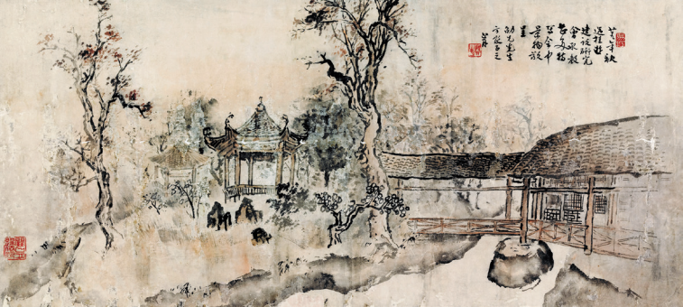
Figure 1 "Garden Scene of the Guangxi Construction Research Association" by Guan Shanyue Chinese Painting 40.7cm × 80.4cm 1940
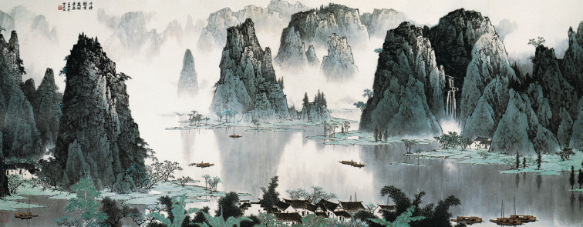
Figure 2 "Countless Peaks Vying in Splendor, Myriad Trees Flourishing in Glory" by Bai Xueshi Chinese Painting 169cm × 630cm 1992

Historical heritage and resource advantages of Guangxi's fine arts
Guangxi Zhuang Autonomous Region is located in the southern frontier of the motherland and is home to 12 long-standing ethnic groups, boasting a rich historical and cultural tradition. The achievements in ethnic fine arts creation are remarkable. The world cultural heritage "Huashan Rock Paintings" represent the best-preserved, largest, and longest-lasting "thematic" paintings in the world today. They are a great creation of the ancestors of the Zhuang people in southern China from the Warring States period to the Eastern Han Dynasty. The renowned Qing Dynasty painter Shitao was from Guangxi. Especially in modern and contemporary times, Guangxi has played a significant role in the development of Chinese culture. During the Anti-Japanese War, the "Guilin Cultural City" gathered over 200 famous cultural figures, including Xu Beihong, Huang Binhong, Zhang Daqian, Feng Zikai, He Xiangning, Zhao Shao'ang, Li Keran, Guan Shanyue, Yang Taiyang, Ma Wanli, and Zhang Anzhi, who made important contributions to the "War of Resistance Culture" and the development of fine arts creation and education in Guangxi.
Guangxi is also endowed with stunning natural landscapes and colorful ethnic customs. It is home to the "Red River Culture" of the Zhuang people's mother river, the "Red Culture" of the "Baise Uprising" and the "Xiangjiang River Campaign," and the "Maritime Culture" of the Beibu Gulf, the earliest starting port of the ancient maritime Silk Road. Additionally, it is a key region for China-ASEAN cooperation and the "Belt and Road" initiative. Since the founding of the People's Republic of China, fine arts creation in Guangxi has achieved unprecedented development and remarkable accomplishments. In the 21st century, Guangxi's fine arts creation has gained significant influence across the country.
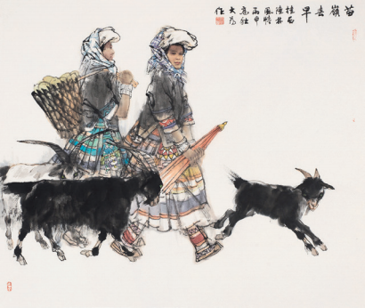
Figure 3 "Early Spring in Miao Mountains" by Liu Dawei Chinese Painting 121cm × 144cm 2016
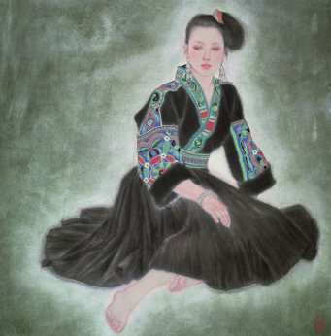
Figure 4 "Dong Sister" by Jiang Caiping Chinese Painting 80cm × 80cm 1988
To review the development of modern and contemporary art creation in Guangxi, especially the progress in ethnic-themed art, and to showcase the significant contributions made by Guangxi as a subject, we organized this exhibition. Guangxi is also blessed with breathtaking natural landscapes and rich ethnic customs. It is home to the "Red River Culture" of the Zhuang people's mother river, the "Red Culture" represented by the "Baise Uprising" and the "Battle of Xiangjiang River," and the "Maritime Culture" of the Beibu Gulf, the earliest departure port of the ancient Maritime Silk Road. Additionally, as a key region in China-ASEAN cooperation and the "Belt and Road" initiative, Guangxi's art creation has achieved unprecedented development and outstanding accomplishments since the founding of New China. Entering the 21st century, Guangxi's artistic creation has gained significant influence across the country.
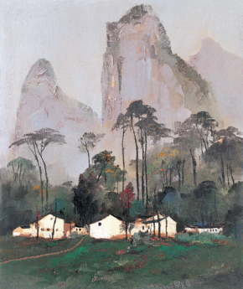
Figure 5 "Countryside in Guilin" by Wu Guanzhong Oil Painting 73cm × 61cm 1980
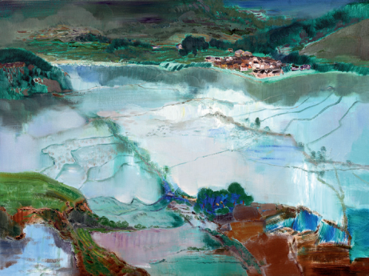
Figure 6 "Homeland" by Xu Li Oil Painting 90cm × 120cm 2015

Exhibition structure and organization
To systematically review the development of modern and contemporary Guangxi art, particularly ethnic-themed art, and to showcase the artistic achievements centered on Guangxi, the "Beautiful South· Guangxi—Chinese Fine Art Exhibition" was specially organized. This exhibition serves as a documentary showcase by the China Artists Association, chronicling the history and development of national ethnic art creation. The exhibition is divided into three sections: "Historical Classics," "Guangxi Art," and "Art in Guangxi."
The "Historical Classics" section features renowned works from the collection of the National Art Museum of China, including masterpieces by artists such as Qi Baishi, Xu Beihong, Huang Binhong, Zhang Anzhi, Guan Shanyue, Yang Taiyang, Wu Guanzhong, Huang Dufeng, and Ma Wanli. Additionally, it includes case studies of 11 artists: Xu Beihong, Li Keran, Zhang Anzhi, Guan Shanyue, Bai Xueshi, Zhou Lingzhao, Ma Wanli, Yang Taiyang, Huang Dufeng, Tu Ke, and Zong Qixiang.
The "Guangxi Art" section highlights the achievements of Guangxi's art creation across different periods since the founding of the People's Republic of China, as well as the latest creative accomplishments.
The "Art in Guangxi" section showcases works created by renowned artists from across the country who drew inspiration from Guangxi during their visits.
To ensure the success of this exhibition, the China Artists Association organized over 100 artists in four batches to visit Guangxi for inspiration, resulting in a collection of outstanding artworks. The Guangxi Artists Association mobilized artists across the autonomous region to contribute, recommending 200 pieces for selection. Additionally, representative works from various historical periods related to Guangxi's art creation were borrowed or specially invited from the National Art Museum of China. The exhibition also includes select works from the Guangxi Modern and Contemporary Major Historical Themes Art Project, as well as entries submitted from across the country.
In total, the exhibition features 380 artworks, providing a comprehensive representation of the development of Guangxi's art creation over the past century. Accompanying the exhibition, a large-scale documentary album titled Beautiful South· Guangxi—Chinese Fine Art Exhibition Collectionwas published, and a documentary film was produced to commemorate the event.
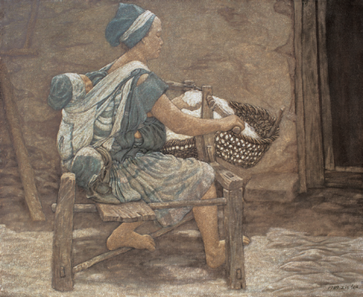
Figure 7 "Spinning Cotton" by Xie Lin Oil Painting 90cm × 100cm 1989
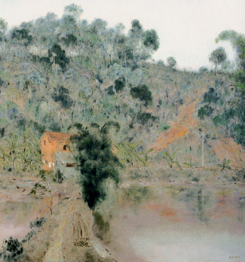
Figure 8 "Homeland" by Zhang Dongfeng Oil Painting 160cm × 150cm 1999
The Publicity Department of the CPC Guangxi Zhuang Autonomous Regional Committee, the Guangxi Federation of Literary and Art Circles, and the Guangxi Artists Association regarded this event as a measure to implement the spirit of General Secretary Xi Jinping's "speech" at the Symposium on Literature and Art, and to carry out the creation of literary and artistic masterpieces under the theme "Beautiful South·Stories of Guangxi." They provided strong support for the exhibition. This also served as a significant showcase of the achievements in Guangxi's cultural endeavors, particularly in the field of fine arts creation. It will help establish a new cultural and artistic image of Guangxi nationwide and make an important contribution to comprehensively promoting the new development of fine arts creation in Guangxi.
The academic seminar for the exhibition was held at the National Art Museum of China at 1:30 p.m. on December 9.

Conclusion
This article reports on the grand opening and background of the "Beautiful South· Guangxi—Chinese Fine Art Exhibition." It highlights that the exhibition is a continuation of the national fine arts series of academic activities initiated by the China Artists Association since 2009. Drawing on Guangxi's multi-ethnic historical and cultural resources, the legacy of the "Guilin Cultural City" during the Anti-Japanese War, and its picturesque natural landscapes, the exhibition comprehensively showcases the development of Guangxi's fine arts creation over the past century through three sections: "Historical Classics," "Guangxi Art," and "Art in Guangxi."
The exhibition organized over a hundred artists to visit Guangxi for inspiration, published a large-scale documentary album, and produced a documentary film. It serves both as a concrete implementation of the spirit of General Secretary Xi Jinping's speech at the Symposium on Literature and Art and as a significant showcase of the achievements in Guangxi's cultural endeavors, particularly in fine arts creation. The exhibition plays a vital role in promoting the new development of fine arts in Guangxi.

