Research on the modification technology of beta molecular sieve

Henry Jackson1, a, *, Katherine Wilson1, b, Noah Miller1, c,

1University of Ottawa,800 King Edward Avenue, P.O. Box 450 S tn. A, Ottawa, Ontario, K1N 6N5, Canada

a.heneyjk_2005@sina.com, [b.kw_15420_125@gmail.com](mailto:b.kw_15420_125@gmail.com), c.noah2024_stud@126.com

**\*Corresponding Author**

**Abstract**: The influence of temperature and time of the acid washing and hydrothermal treatment on Beta zeolite properties was examined in detail, the results revealed that acid washing at 2h and 80℃and 2h hydrothermal treatment at 650℃are the best modification operating conditions. The different SiO2/Al2O3ratio of Beta zeolite are systematically modified using optimized modification operating conditions. Beta zeolite modified from higher SiO2/Al2O3ratio of the starting Beta also has higher SiO2/Al2O3 ratio. Crystallinity of starting Beta zeolite has less effect on the modified Beta zeolite. As the SiO2/Al2O3 ratio of starting Beta increased, total acid amount of modified Beta decreased. When the SiO2/Al2O3 ratio of starting Beta is bigger, the surface area and pore volume is higher.

**Key words**: Beta zeolite, Modification technology, Acid washing, Hydrothermal treatment

# Introduction

High-silica Beta molecular sieves with large pores were first synthesized by Wadlinger et al. from Exxon Mobil Corporation in 1967[1]. In 1988, Higgins et al.[2] and Newsam et al.[3] revealed the three-dimensional structural characteristics of Beta molecular sieves. The silicon-to-aluminum ratio (hereinafter referred to as Si/Al ratio) in the framework of Beta molecular sieves is generally between 10 and 200. It is the only high-silica molecular sieve with a three-dimensional large-pore dodecasil three-cage structure [4]. Its molecular formula is: ${Na}_{n}[{AI}_{n}{Si}_{64-n}O_{128}]$,n<7｡Beta molecular sieves are known for their good hydrothermal stability, shape-selectivity, and adjustable acidity, which contribute to their excellent anti-coking properties and catalytic activity. When modified, Beta molecular sieves can be widely applied in various petroleum and chemical processes such as catalytic cracking and hydrocracking [5]. Therefore, the author used Beta molecular sieves with a silicon-to-aluminum ratio (referred to as Si/Al ratio hereinafter) of 25 as raw material to investigate the effects of acid washing and hydrothermal treatment temperature and duration on the properties of Beta molecular sieves. Under the optimal modification conditions, molecular sieves with Si/Al ratios of 20, 25, and 30 were modified to observe the effects on the skeletal Si/Al ratio, relative crystallinity, X-ray diffraction peak intensity, and pore structure.

# Experimental section

## Reagents and apparatus

Beta Molecular Sieve: With a relative crystallinity of 80%, silicon-to-aluminum ratios of 20, 25, and 30, homemade; Concentrated hydrochloric acid: With a mass fraction of 36% to 38%, Guangzhou De Shu Chemical Co., Ltd.

DGG-9023A Drying Oven: Shanghai Sen Xin Laboratory Instruments Co., Ltd.; SX2-4-10 Muffle Furnace: Jin Tan City Rong Hua Instrument Manufacturing Co., Ltd.; AL104 Electronic Balance: Mettler-Toledo Instruments (Shanghai) Co., Ltd.

Rigaku D/max-2500PC X-ray Diffractometer: Cu Kα radiation, λ = 0.1541841 nm; Rigaku Corporation, Japan; Tristar 3000 Specific Surface Area and Porosity Analyzer: Micromeritics Instrument Corporation, USA; GX-2000 Spectrometer (P y-IR): PerkinElmer Corporation, USA; Mag ix 601 X-ray Fluorescence Spectrometer (XRF): Philips Company, Netherlands.

## Modification method of Beta molecular sieve

Using Beta molecular sieve with a silicon-to-aluminum ratio of 25 as the raw material, it was acid-washed with hydrochloric acid solution at a certain temperature for 1 hour, then rinsed with distilled water to remove chloride ions, dried overnight at 110°C, and then subjected to hydrothermal treatment in a 100% steam atmosphere at 650°C. The acid-washing and hydrothermal treatment processes were repeated to investigate the effects of acid-washing and hydrothermal treatment temperatures and durations on the properties of the Beta molecular sieve, and the optimal modification process was determined. After determining the suitable acid-washing temperature and hydrothermal treatment temperature, three types of molecular sieves with silicon-to-aluminum ratios of 20, 25, and 30, namely Beta1, Beta2, and Beta3, were modified to obtain Beta4, Beta5, and Beta6 molecular sieves.

# Results and discussion

## Optimization of Beta molecular sieve modification process conditions

### The effect of acid washing temperature

Starting with sodium-type Beta molecular sieve as the raw material (with a silicon-to-aluminum ratio of 25), the molecular sieve was acid-washed at 60, 70, 80, and 90°C, respectively. The effects of acid-washing temperature on the relative crystallinity and sodium content (w(Na)) of the Beta molecular sieve were determined, and the results are shown in Figure 1.

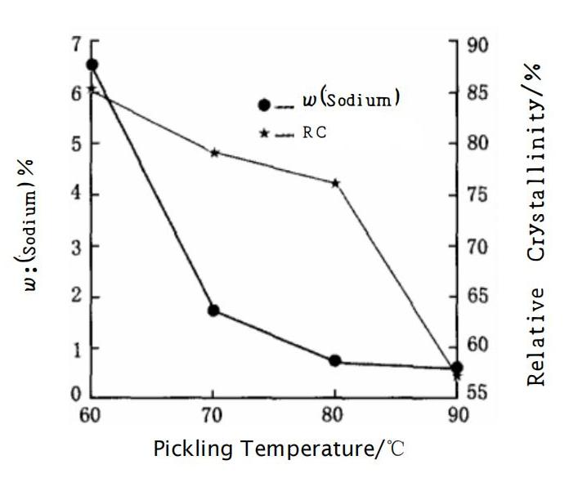

Figure 1 The Effect of Acid Washing Temperature on Sodium Content (w(Na)) and Crystallinity

As can be seen from Figure 1, the sodium content (w(Na)) of the Beta molecular sieve decreases significantly with the increase of acid washing temperature. When the acid washing temperature exceeds 80°C, the sodium content (w(Na)) of the Beta molecular sieve is less than 1%. Under high-temperature acid washing conditions, the sodium content (w(Na)) of the Beta molecular sieve changes very little, while the relative crystallinity decreases significantly. Therefore, the optimal acid washing temperature for the modification of Beta molecular sieve is 80°C.

### The effect of acid washing time

Under the condition of acid washing temperature at 80°C, Beta molecular sieves with a silicon-to-aluminum ratio of 25 were acid-washed for 1, 2, and 3 hours, respectively, to investigate the effect of acid washing time on relative crystallinity. The results are shown in Figure 2.

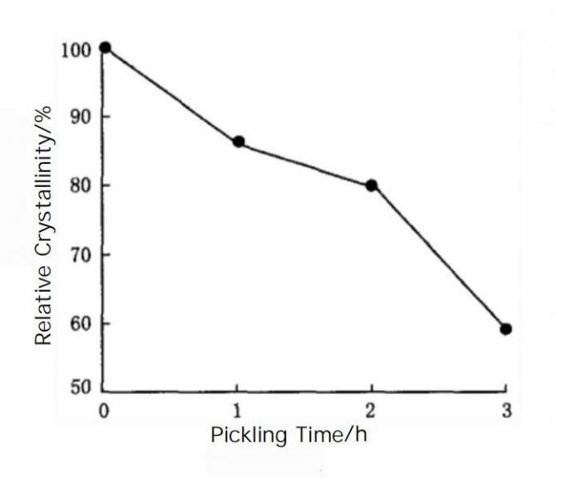

Figure 2 The Effect of Acid Washing Time on the Relative Crystallinity of Beta Molecular Sieve

As shown in Figure 2, the relative crystallinity of the Beta molecular sieve decreases with the increase of acid washing time. After acid washing for 1, 2, and 3 hours, the relative crystallinity of the Beta molecular sieve is reduced to 86%, 80%, and 59%, respectively. Since the loss of crystallinity after 3 hours of acid washing is very significant, acid washing for 2 hours is sufficient.

### The Effect of Hydrothermal Treatment Temperature

Hydrothermal treatment can effectively alter the relative crystallinity, the amount of L acid and B acid of molecular sieves. Beta molecular sieves that have been acid-washed twice at 80°C were subjected to hydrothermal treatment. The influence of hydrothermal treatment temperature on the relative crystallinity, L acid, and B acid of the Beta molecular sieve product was examined, and the results can be seen in Table 1.

Table 1 The Effect of Hydrothermal Treatment Temperature on B Acid, L Acid, and Crystallinity

|  |  |  |  |  |
| --- | --- | --- | --- | --- |
| Hydrothermal Treatment Temperature /℃ | B Acid / (mmol·g-1) | L Acid/ (mmol·g-1) | B Acid / L Acid | Relative Crystallinity /% |
| 550 | 0.107 | 0,103 | 1.04 | 88 |
| 600 | 0.099 | 0,101 | 0,97 | 85 |
| 650 | 0,086 | 0.092 | 0,93 | 80 |
| 700 | 0.053 | 0.078 | 0,68 | 61 |

As shown in Table 1, with the increase of hydrothermal treatment temperature, both the amounts of B acid and L acid tend to decrease, and the value of B acid/L acid also gradually decreases, indicating that the proportion of B acid decreases while the proportion of L acid increases. Since L acid sites are more prone to carbon deposition, a higher B acid/L acid ratio is beneficial for improving the activity stability of the catalyst. When the hydrothermal treatment temperature is 650°C, the B acid/L acid value and relative crystallinity of the Beta molecular sieve do not decrease significantly, therefore 650°C is a more suitable hydrothermal treatment temperature.

### The effect of hydrothermal treatment time

Starting with Beta molecular sieve with a silicon-to-aluminum ratio of 25 as the raw material, the effect of hydrothermal treatment time on the relative crystallinity of the molecular sieve was investigated under conditions of acid washing at 80°C for 2 hours and hydrothermal treatment at 650°C. The results can be seen in Figure 3.

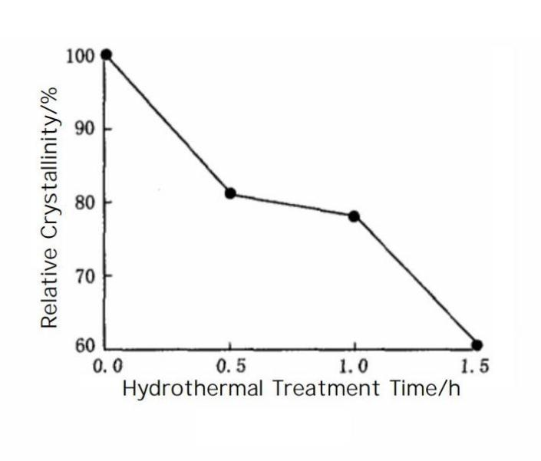

Figure 3 The Effect of Hydrothermal Treatment Duration on Relative Crystallinity

As shown in Figure 3, the relative degree of crystallinity decreases with the increase of hydrothermal treatment time, with the relative crystallinity dropping from 100% to 81%, 78%, and 60% respectively. When hydrothermal treatment is carried out for 1.5 hours, the loss of crystallinity is significant, so hydrothermal treatment for 1 hour is sufficient.

## Modification study of Beta zeolites with different Si/Al ratios

### X-ray diffraction (XRD)

The modification method involving acid washing at 80°C for 2 hours and hydrothermal treatment at 650°C for 1 hour was applied to Beta1, Beta2, and Beta3 zeolites with Si/Al ratios of 20, 25, and 30, respectively. After modification, they were named Beta4, Beta5, and Beta6 zeolites. The XRD patterns of Beta1 to Beta6 zeolites can be seen in Figure 4.

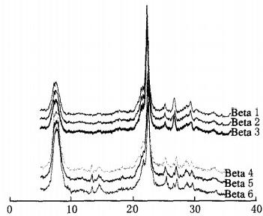

20/ (°)

Figure 4 XRD Patterns of Beta Zeolites

The skeletal Si/Al ratios and relative crystallinities of the six Beta zeolites are presented in Table 2. As can be seen from Figure 4 and Table 2, although the crystallinity of the three zeolite products did not improve after modification, the diffraction peaks were significantly enhanced. This is because the intensity of the X-ray diffraction peaks of Beta zeolites is related not only to the crystallinity but also to the aluminum content of the zeolites [6]. From Table 2, it is evident that under the same modification conditions, the Si/Al ratio has little effect on the relative crystallinity; as the Si/Al ratio increases, both the total acidity and the B acid/L acid ratio decrease.

Table 2 Si/Al Ratio, Acidity, and Relative Crystallinity of Beta Zeolites

|  |  |  |  |  |  |
| --- | --- | --- | --- | --- | --- |
| Molecular Sieve | Silicon-Aluminum Ratio | B Acid / (mmol/g) | L Acid / (mmol/g) | B Acid/L Acid Ratio | Relative Crystallinity /% |
| Beta1 | 20 | 0.163 | 0.149 | 1.09 | 98 |
| Beta2 | 25 | 0.155 | 0.136 | 1.14 | 97 |
| Beta3 | 30 | 0.154 | 0.135 | 1.14 | 99 |
| Beta4 | 46 | 0.111 | 0.091 | 1.22 | 77 |
| Beta5 | 7 | 0.096 | 0.086 | 1.12 | 78 |
| Beta6 | 73 | 0.077 | 0.089 | 0.87 | 80 |

### Pore structure analysis (BET)

The pore structure data of the six Beta zeolites can be found in Table 3. From the pore structure data of the six Beta zeolites in Table 3, it can be observed that the specific surface area of the modified Beta zeolites has decreased, while the mesopore surface area and mesopore volume have increased significantly. Consequently, the micropore surface area and micropore volume have also decreased, indicating that the modified Beta zeolites have generated more mesopores. This is beneficial for large molecules such as aromatics to enter the active centers inside the catalyst pores and quickly diffuse out after the reaction, thus avoiding secondary cracking reactions. A comparison of the three modified Beta zeolites shows that the higher the Si/Al ratio of the Beta zeolite, the larger the specific surface area and the greater the pore volume.

Table 3 Pore Structure Data of Beta Zeolites

|  |  |  |  |  |  |
| --- | --- | --- | --- | --- | --- |
| Molecular Sieve | Specific Surface Area / (m²/g) | Micropore Surface Area / (m²/g) | Mesopore Surface Area / (m²/g) | Micropore Volume / (ml/g) | Mesopore Volume / (ml/g) |
| Beta1 | 664 | 601 | 63 | 0.42 | 0.05 |
| Beta2 | 673 | 613 | 60 | 0.44 | 0.07 |
| Beta3 | 661 | 592 | 69 | 0.43 | 0.06 |
| Beta4 | 520 | 315 | 205 | 0.20 | 0.35 |
| Beta5 | 541 | 318 | 223 | 0.25 | 0.36 |
| Beta6 | 571 | 353 | 218 | 0.27 | 0.38 |

# Conclusions

Taking Beta zeolite with a Si/Al ratio of 25 as an example, the effects of acid washing temperature, acid washing time, hydrothermal treatment temperature, and hydrothermal treatment time on the properties of Beta zeolite were investigated. The conclusions are as follows:

Firstly, the modification process for Beta zeolite is acid washing at 80°C for 2 hours and hydrothermal treatment at 650°C for 1 hour;

Secondly, under the same modification conditions, the higher the Si/Al ratio of the Beta zeolite raw material, the higher the Si/Al ratio of the modified Beta zeolite product, while the relative crystallinity remains essentially unchanged. With the increase of the Si/Al ratio, the total surface acid amount of Beta zeolite decreases. The higher the Si/Al ratio of the Beta zeolite obtained after modification, the larger the specific surface area and the greater the pore volume.

# References

1. WANDLINGER R L, KERR G T, ROSINSKI E J. Catalytic composition of a crystalline zeolite:3308069 [P].1967- 03-07.
2. HIGGINS J B, LAPIERRE R B, SCHLENKER J L, et al The framework topology of zeolite beta[J]. Zeo lites,1988, 8(6):446-452.
3. NEWSAM JM, TREACY MM J, KOETSIER WT, et al. Structural characterization of zeolite beta[J]. Proc R Soc Lond A,1988,420:375-405.
4. KNIFTON, JOHN F D, PEI-SHING E. One step synthesis of ethyl t- butyl ether from t-butanol using beta-zeolite and multimetal modified beta-zeolite catalysts: 5449839 [P]. 1995-09-12.
5. Du Yan ze, Qiao Nansen, Wang Feng lai, et al. Study on the catalytic performance characteristics of β zeolite in hydrocracking reaction [J]. Petroleum Refining and Chemical Industry, 2011, 42(8): 22-26.
6. KIRICSI I, FLEGO C, PAZZUCONI G, et al. Progress toward understanding zeolite beta acidity: an IR and 27Al NMR spectroscopic study[J]. J Phys Chem,1994,98 (17):4627-4634.